**Lab Assignment #3**

GitHub link: <https://github.com/ItsYourFriendFred/c304Lab3>

Screenshots:

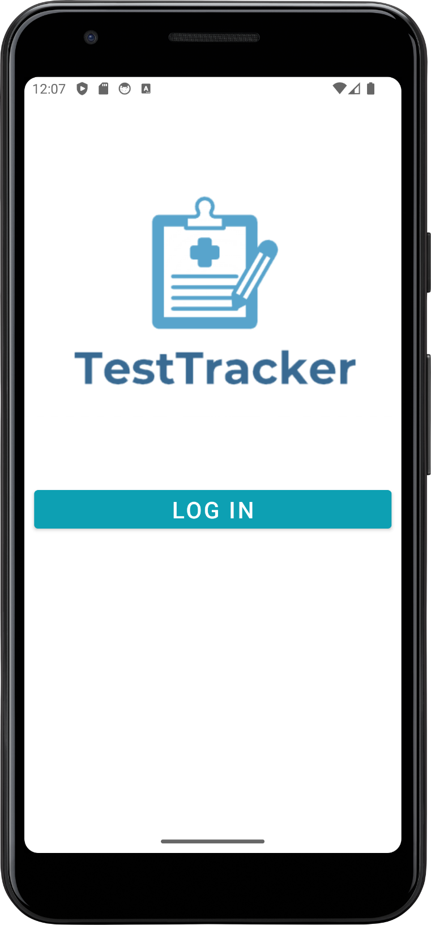

Figure 1. Splash screen activity that leads to login activity

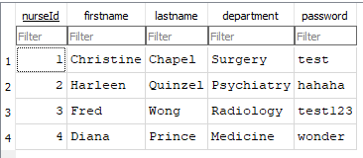

Figure 2. Login activity. Username uses Nurse ID. An account consisting of username: 1 & password: test may be used for browsing and testing. Features validation for existing accounts and that the inputs aren’t blank.

Figure 3. Main activity listing all patients. The user can add a patient using the floating action button or through the action bar menu. The user can click on an existing patient to bring up their information for viewing or editing.

Figure 4. Adding a patient through the Patient activity. The Nurse ID is pre-populated using Shared Preferences; the field is disabled and the ID is automatically used during data insertion. Features validation that the name fields aren’t blank.

Figure 5. Main activity after a patient has been added.

Figure 6. Updating a Patient’s information through the UpdateInfo activity.

Figure 7. Main activity showing the updated patient information.

Figure 8. Clicking View Tests from the UpdateInfo activity instead brings the user to the ViewTestInfo activity that lists all of the particular patient’s tests. Clicking the floating action button or using the action bar menu leads to adding a test.

Figure 9. Test activity where the user can add a test. The Nurse ID is pre-populated using Shared Preferences; the field is disabled and the ID is automatically used during data insertion. Features validation that the fields aren’t blank.

Figure 10. Filling in the fields and then adding a test.

Figure 11. The ViewTestInfo activity after adding the new test. The list is implemented as a RecyclerView.

Figure 12. Using the newly created Patient, Bruce Wayne with Patient ID 3, their ViewTestInfo activity starts as an empty list since no tests have been added yet. A message is shown when the list is empty.